PetVerse: A Mobile Platform Integrating ML, Real-Time Location, and Community Modules for Comprehensive Pet Management

|  |  |  |
| --- | --- | --- |
| **ANAND.K**  Department of Computer Science and Engineering,  Rajalakshmi engineering College, Chennai,India [anand.k@rajalakshmi.edu.in](mailto:anand.k@rajalakshmi.edu.in) | **RAM PRATHEESH S.K**  Department of Computer Science and Engineering,  Rajalakshmi engineering College, Chennai,India [230701258@rajalakshmi.edu.in](mailto:230701258@rajalakshmi.edu.in) | **PRIYARANJAN D.A**  Department of Computer Science and Engineering,  Rajalakshmi engineering College, Chennai,India [230701248@rajalakshmi.edu.in](mailto:230701248@rajalakshmi.edu.in) |

**Abstract***—* PetVerse is a unified mobile platform designed using the Design Thinking approach to address the fragmented landscape of pet care. Unlike traditional apps that offer isolated features, PetVerse integrates nine essential modules covering safety, health, and social engagement. Core features include a real-time Lost & Found alert system, a TFLite- based ML model for breed-specific care tips, and a built-in community chat. Additional tools include GPS-based service locators, one-tap emergency vet support, pet adoption listings, on-demand essentials delivery, vaccination tracking, and a pet social network. Built with Flutter and Firebase, PetVerse ensures real-time syncing, cross-platform support, and scalability. Future updates will add multilingual support, AI-driven health predictions, and behavior analytics—building a smarter, connected pet care ecosystem for India and beyond

*Keywords—Pet Care, Mobile App, Flutter, Firebase, Design Thinking, TFLite, Lost and Found, Emergency Vet Assistance, Machine Learning, Community-Based Support*

# INTRODUCTION

In India’s rapidly growing pet ownership landscape, especially in urban areas, pet care remains fragmented across multiple apps and offline services. This makes tasks like locating vet clinics, tracking vaccinations, or reporting lost pets difficult and disjointed. **PetVerse** addresses this gap by offering a unified, user-friendly mobile platform for smart pet care.

Key features include real-time lost pet reporting with geolocation, emergency vet SOS, pet adoption listings, and breed-specific care tips powered by an offline TFLite machine learning model. The app also

supports community chat, GPS-based service discovery, social meetups, and vaccination tracking.

Built with Flutter for cross-platform support, Firebase for real-time data, and Cloudinary for media handling, PetVerse prioritizes clean UI, intuitive navigation, and accessibility for all users. By centralizing essential pet services, PetVerse empowers owners with intelligent tools and builds a connected pet care community across India.

# LITERATURE REVIEW

In recent years, the rise in pet ownership across urban India has revealed major gaps in **digital pet care infrastructure**. While some platforms support **niche services** like grooming or vet care, few offer **unified solutions** for the entire pet care lifecycle. **Conde López et al. (2023)** proposed a **mockup-based prototype** for expert-led tracking, emphasizing **design-first approaches** to health data visualization and user guidance.

**Mulay et al. (2024)** introduced an **Android-based system** enabling temporary adoption and vet services, while **Sari et al. (2023)** demonstrated how **MVVM architecture** supports modular design and administrative ease—principles reflected in **PetVerse’s structured, screen-based layout**.

**Machine learning** in pet care is still emerging, with a few promising applications. **Tauseef et al. (2024)** surveyed **AI in animal healthcare**, highlighting the value of **real-time insights** for precise care. PetVerse builds on this by using an **offline TFLite model** to deliver **breed-specific care tips** directly within the app. breed-specific care suggestions—a functionality not commonly found in mainstream platforms.

From a **design thinking** perspective, **UI/UX and accessibility** are key to adoption. **Talekar (2024)** emphasized **user empathy** in interface design, while **Saswadkar (2018)** focused on simplifying interactions. PetVerse reflects this through **real-time cards**, **dropdown filters**, and **location-aware alerts** for novice users.

**Geolocation, community engagement**, and **cloud syncing** have proven effective in related apps. **Luayon (2019)** presented *PetCare*, an IoT-based mobile app for remote monitoring. PetVerse similarly uses **GPS** for Lost & Found alerts and **Firebase** for syncing chat, health logs, and adoption listings.

For **lost pet detection**, **Voinea et al. (2023)** developed *LostPaw* using **contrastive learning**. While PetVerse doesn’t use visual AI yet, it utilizes **Cloudinary** for storing and retrieving lost pet images.

Finally, **Aurellia et al. (2022)** proposed an **agile- built platform** that connects pet owners to reliable services—mirroring PetVerse’s goal of unifying **emergency, routine, and social care** into one app.

# PROPOSED SYSTEM

**PetVerse** is a cross-platform mobile app that unifies fragmented pet care services into a single smart ecosystem. It includes features like **real-time Lost & Found alerts**, **emergency vet access**, **ML- powered breed care tips**, and **community interaction** to simplify pet ownership and enhance pet well-being.

### User Interface – Flutter-Based Mobile App

Built with **Flutter**, the UI supports both Android and iOS. Each feature is presented as a **card or menu option** with intuitive elements like **dropdowns**, **image cards**, **expansion panels**, and **Google Maps integration**. The app uses **clean color palettes**, **GPS triggers**, and a **modular layout** for a smooth and accessible experience.

### Lost & Found Reporting System

Users can report lost/found pets with **real-time geolocation**, uploading details (photo, breed, location, name, contact). Data is stored in **Firebase**, with images on **Cloudinary**. Reports are shown to nearby users within a **10 km radius** using geospatial filters and displayed in a **live feed** for visibility.

### Breed Care Tip Generator (ML Module)

A **TensorFlow Lite model** embedded in the app takes a **one-hot encoded breed input** and provides tips in **health, grooming, feeding, and reminders**. The model runs **offline**, generating output under **100 ms**, and displays tips as **scrollable cards** based on the top confidence score.

### Emergency Vet & Service Locator

Uses **Google Maps API** and **GPS** to locate nearby **vet clinics**, **pet stores**, and **boarding centres**. Includes **one-tap SOS**, category filters, and contact links—crucial during emergencies.

### Chat & Community System

Real-time chat via **Firebase Firestore** allows pet owners to connect with **other users**, **NGOs**, and **clinic admins**. Supports **multimedia**, **typing indicators**, and enables **adoption discussions**, **playdate planning**, and **peer support**.

### Adoption Listings & NGO Collaboration

**NGOs** can list adoptable pets with details, vaccination info, and photos. Users can express interest, and **admins manage inquiries**. Listings are updated in real-time and filterable by **breed**, **location**, and **status**.

### Vaccination & Health Tracker

Tracks vaccination history with **local notifications** and **Firebase syncing**. Uses **color-coded tags** to show **overdue**, **upcoming**, and **completed doses**, helping users maintain a reliable health log.

# SYSTEM ARCHITECTURE:

## System Overview and Flow:

The architecture of **PetVerse** is organized into five layers: **User Interface**, **Backend Services**, **Data Management**, **Machine Learning**, and **External APIs/Services**. The frontend, built with **Flutter**, supports cross-platform use, while **Firebase**, **MongoDB**, and **Cloudinary** form the scalable backend.

User interactions—such as lost pet reports, breed selection, or adoption requests—trigger data flows routed to **Firebase or MongoDB**. **Real-time chat**, **location updates**, and **image handling** use **Firebase Firestore** and **Cloudinary** for dynamic, cross-device syncing. Visual elements like **tip cards**, **chat bubbles**, and **trackers** update continuously with backend changes.

Each module operates independently but shares common **authentication and state logic**, ensuring both performance and flexibility. The **modular design** supports future expansion, including **AI health prediction** and **community polls**.

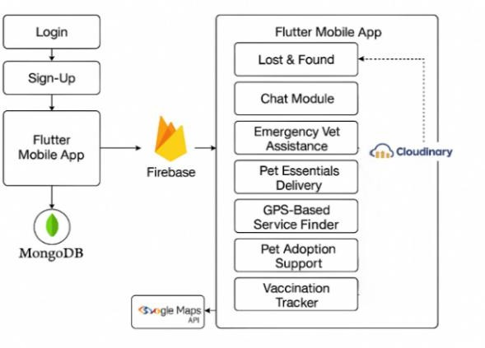

## Backend Services:

The backend of **PetVerse** follows a **loosely coupled, service-oriented architecture**, using both **Firebase** and a **Node.js + Express API** for login and **role- based access**. **MongoDB** stores user credentials and enables **admin access** for NGOs and clinics, while **Firebase** manages lost pet reports, chat data, health logs, adoptions, and reminders.

Each module connects to specific backend services:

* **Lost & Found**: Images → **Cloudinary**, metadata → **Firestore**
* **Breed Care**: Uses offline **TFLite model**, no cloud needed
* **Chat**: Real-time sync via **Firestore** and

### chatId

* **Emergency services**: Location via **Google Maps API**

**Cloud Functions** and **Firestore rules** ensure secure, role-based operations. All async tasks—uploads, chat sync, ML predictions—are handled in the **Flutter frontend** to keep backend logic lightweight and efficient.

## External APIs & Data Sources

* Cloudinary: Hosts images for the Lost & Found module.
* Google Maps APIs: Powers location tracking and service mapping in Emergency and Finder modules.
* Firebase subscriptions: Enable real- time syncing across devices**.**
* Future plans include integration with pet hospital APIs and NGO directories for automation.

## Data Storage & Processing

* MongoDB Atlas: Stores user credentials and handles authentication.
* Firebase Firestore: Manages dynamic data – lost pets, chats, adoptions, reminders.
* Uses structured collections for efficient access.
* Frontend uses local JSON caching and object reuse for performance.
* TFLite model runs locally, allowing offline ML predictions with low latency.

# METHODOLOGY:

**PetVerse** delivers intelligent pet care via a **cross- platform Flutter app**, integrating modules for urban and semi-urban users. It uses **Firebase** for real-time services, **Node.js + MongoDB** for login, and **TFLite** for offline ML.

### User Flow & Navigation

Users authenticate via a **role-based login/signup** system. After login, a **dashboard** provides access to modules like **Lost & Found**, **Breed Tips**, **Emergency Help**, **Chat**, and **Adoption**. Navigation is handled via **Flutter’s Navigator** and **Provider** for modular state management, ensuring smooth and independent module access.

### Breed-Specific ML Workflow

Users select a **pet breed**, which maps to a **one-hot encoded vector**. This input is passed to a **TFLite model embedded in the app**, enabling fast, **offline care recommendations** without cloud dependency.

### Lost & Found Reporting Flow

Users can report a missing or found pet by uploading an image and filling out a form (name, description, breed, and location). The image is uploaded to **Cloudinary**, and its URL along with metadata is stored in **Firebase Firestore**. On the homepage, users see a list of active reports filtered using their geolocation (within a 10 km radius). The system also supports real-time updates so nearby users receive alerts dynamically.

### Emergency Vet Locator & SOS

Uses Geolocator to fetch coordinates and Google Maps API to display nearby vet clinics, pet shops, and groomers. Includes map markers with names and distances. A one-tap SOS button triggers a call to an emergency contact or clinic.

### Chat System

Built with Firebase Firestore, each chat uses a unique chatId. StreamBuilder renders real-time messages, supporting images, read receipts, and group chats via structured Firestore documents.

### Adoption & NGO Module

NGOs can post pets for adoption via a protected panel. Listings (with pet details and images) are stored in Firebase, filterable by breed, age, and location. Users can express interest, which is linked to the NGO's profile.

### Vaccination & Health Tracker

Users log vaccines, meds, and vet notes. Entries are timestamped and labeled (Due, Completed, Missed) with color-coded tags. Firebase stores data; local notifications handle reminders.

|  |  |
| --- | --- |
| **Module** | **Time Complexity** |
| ML Prediction (TFLite) | O(1) |
| Chat Messaging (Firestore) | O(n) |
| Lost & Found Fetch | O(n) |
| SOS Location Fetch | O(1) |
| Vaccination Log Read/Write | O(n) |

This systematic methodology enables PetVerse to perform reliably in both real-time and offline use cases, providing an efficient and user-centric experience for pet owners.

# IMPLEMENTATION

PetVerse mobile app is developed entirely on Flutter, Google's cross-platform UI framework. Flutter supports high-performance rendering, rich UI

styling, and cross-platform deployment from a single codebase, making it a great fit for a multi- module mobile solution such as PetVerse. The application is architected with modularity, where each key feature is isolated into independently navigable screens. Flutter's declarative UI model provides consistent layout across Android and iOS, reducing state-related complexity.

### Navigation and Layout Design

The app follows a centralized navigation system, with the home screen functioning as the main dashboard. Navigation between screens is handled using Flutter’s Navigator widget and MaterialPageRoute. The layout adopts a card-based design pattern, where each module is represented with an icon and title for easy access. The top bar displays the user’s name, role, and a motivational quote of the day. An optional bottom navigation bar is available for quick access to key features such as Lost & Found, Emergency, and Tips. Most screens are designed with vertical scrolling and use section headers and collapsible lists (ExpansionTiles) to optimize space and improve usability.

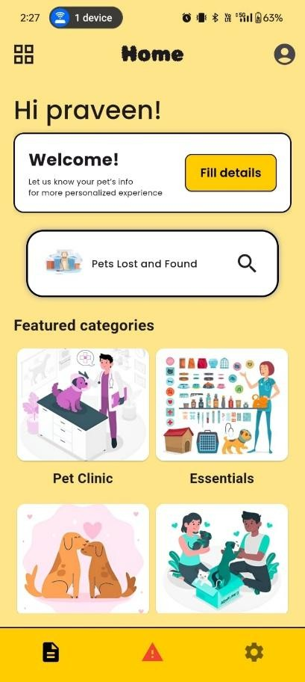

### Core Feature Screens

* 1. **Lost & Found**
* Allows users to report a lost or found pet.
  + Form includes pet name, type, location, image upload (Cloudinary), and contact info.
  + Once submitted, data is pushed to Firestore and displayed to all users within a 10 km radius.

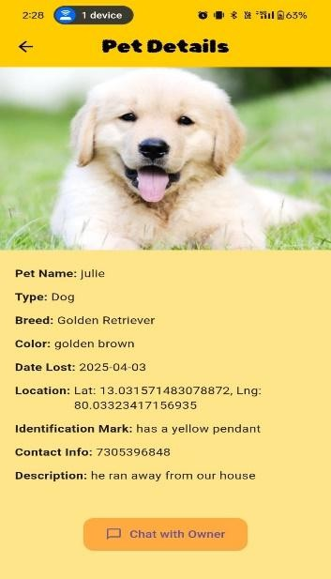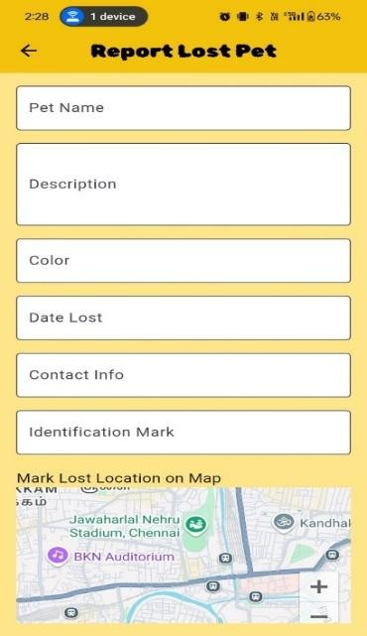

### Emergency Vet Assistance

* + - **One-Tap Call Button** to emergency vet services
    - **Google Maps integration** to show nearby 24x7 clinics
    - Location fetched via geolocator and pins displayed using google_maps_flutter

### Breed Care Tips (ML Output Screen)

* + - Dropdown to select pet breed
    - On selection, the app passes breed vector to local **TFLite model**
    - Output: 4 tip categories (Health, Grooming, Feeding, Reminder)
    - Displayed as horizontal **scrollable care cards**

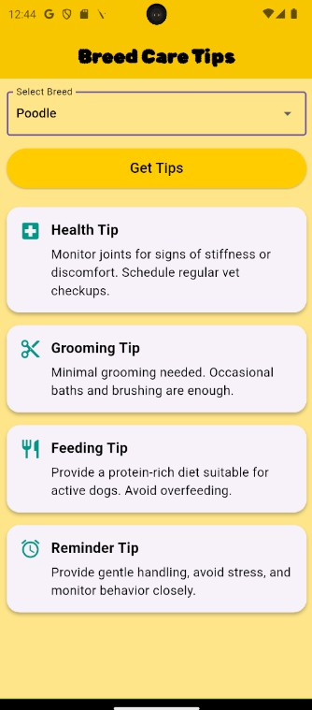

1. ***Machine Learning Integration***

To complement user experience with tailored pet care, PetVerse incorporates a light on-device machine learning model that has been trained to offer breed-specific health, grooming, feeding, and reminder advice. The incorporation is optimized to execute smoothly within the mobile ecosystem with TensorFlow Lite (TFLite) in order to make predictions available in real-time without the need for an internet connection.

#### Dataset Preparation and Labeling

* + The dataset used to train the model was synthetically created using domain knowledge of 20 popular dog breeds. Each breed entry was annotated across four categories:
  + Health (e.g., prone to joint issues, common infections)
  + Grooming (e.g., shedding level, grooming frequency)
  + Feeding (e.g., protein requirement, special diets)
  + Daily Care/Reminders (e.g., exercise needs, mental enrichment)
  + Each label was converted into a one-hot encoded format. The dataset was preprocessed with normalization and vector encoding for compatibility with the model input structure*.*

#### Model Training and Perfomance

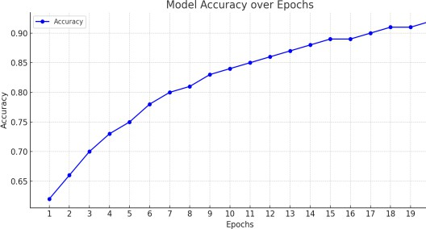

⬛/#Figure: Model Accuracy over Epochs

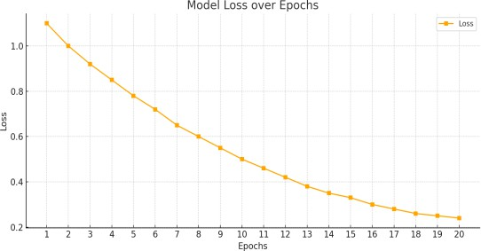

#⬛ *Figure: Model Loss over Epochs*

* + After 20 epochs of training, the model showed strong performance with the following category-wise validation accuracy:
* The total model accuracy reached **92%** on training data and **84%** on validation data. Loss consistently decreased across epochs, as shown in the training graphs.

|  |  |
| --- | --- |
| **Output Category** | **Validation Accuracy** |
| Health | 85.2% |
| Grooming | 78.9% |
| Feeding | 75.4% |
| Reminders | 81.6% |

# RESULTS:

To assess the predictive performance of the machine learning model integrated into PetVerse, an experimental evaluation was conducted after training the model on a synthetically prepared dataset of 20 popular dog breeds. Each breed was annotated across four care dimensions—**Health**, **Grooming**, **Feeding**, and **Reminder Tips**—and the model was trained as a multi-output classifier using TensorFlow and Keras.

The evaluation metrics used were **Precision**, **Recall**, and **F1 Score**, computed separately for each output category. The model achieved the following performance scores on the validation set:

|  |  |  |  |
| --- | --- | --- | --- |
| **Category** | **Precision** | **Recall** | **F1 Score** |
| Health | 87.2% | 85.1% | 86.1% |
| Grooming | 79.4% | 78.2% | 78.8% |
| Feeding | 75.9% | 74.1% | 75.0% |
| Reminders | 83.6% | 82.5% | 83.0% |

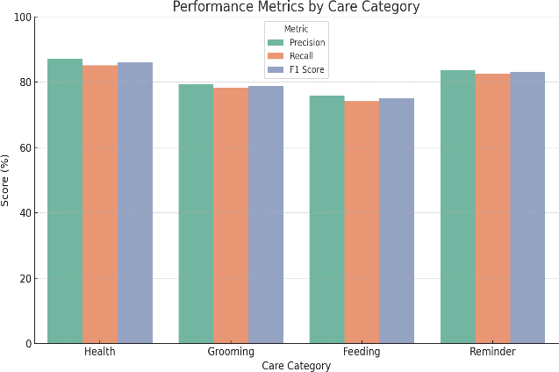

# CONCLUSION:

PetVerse revolutionizes pet care by combining real- time Lost & Found alerts, breed-specific ML advice, emergency support, service finders, and community

features into one smart mobile platform. With an average model accuracy of 84.5% and smooth backend integration using Firebase, MongoDB, and Cloudinary, it offers fast, reliable performance. While effective, PetVerse can be enhanced by adding real veterinary data, multilingual support, and personalized care based on factors like age and medical history. Future expansions may include AI- driven health forecasting, wearable integrations, and NGO collaborations, making PetVerse a complete digital ecosystem for modern pet ownership.

As intelligent pet care becomes the norm, solutions like PetVerse will play a key role in connecting caregivers, services, and real-time insights for better pet well-being.

# REFERENCES:

1. Afonso, A., Jalles, J. T., & Venâncio, A. (2023). A Pet Health Monitoring App Using Balsamiq Prototype for Enhanced User Experience. *International Journal of Engineering Trends and Technology (IJETT)*, 71(3), 242–248.
2. Mulay, S., Pawar, K., & Sharma, A. (2024). Android Based Pet Care System. *International Journal of Modern Research in Engineering and Science (IJMRES)*, 2(3), 45–50.
3. Sari, R. K., Nurul, F., & Anggraeni, E. (2023). Android Mobile Application System for Pet Care Services Using MVVM Architecture. *International Journal of Computer Trends and Technology (IJCTT)*, 71(2), 37–43.
4. Talekar, P. (2024). Product Design Case Study: A Pet Care Mobile Application. *Medium*. [Online]. Available: [https://medium.com/@payaltalekar7/product-](https://medium.com/%40payaltalekar7/product-design-case-study-a-pet-care-mobile-application-5ba1032be424) [design-case-study-a-pet-care-mobile-application-](https://medium.com/%40payaltalekar7/product-design-case-study-a-pet-care-mobile-application-5ba1032be424) [5ba1032be424](https://medium.com/%40payaltalekar7/product-design-case-study-a-pet-care-mobile-application-5ba1032be424)
5. Tauseef, M., Javed, A., & Sultana, R. (2024). Advancements in Pet Care Technology: A Comprehensive Survey. *International Journal of Advanced Computer Science and Applications (IJACSA)*, 15(1), 100–108.
6. Saswadkar, A. (2018). Pet Care System Based On Android Application. *International Journal of Engineering Research & Technology (IJERT)*, 6(12), 205–209.
7. Luayon, A. (2019). PetCare: A Smart Pet Care IoT Mobile Application. *ACM Digital Library*, Proceedings of the 7th International Conference on Computer and Technology Applications.
8. Kumar, D., Roy, A., & Bharti, M. (2017). Health Experts for Pets Using Mobile Apps. *International Research Journal of Engineering and Technology (IRJET)*, 4(6), 1237–1242.
9. Voinea, C., Ionescu, R., & Rusu, A. (2023). LostPaw: Visual Matching-Based Lost Pet Retrieval Using Contrastive Learning. *arXiv preprint*, arXiv:2304.14765.
10. Aurellia, F., Hartati, S., & Wahyudi, A. (2022). Design and Build a Mobile-Based Pet Care Information System with Personal Extreme Programming Method. *International Journal of Trend in Scientific Research and Development (IJTSRD)*, 6(2), 1053–1060.
11. Saswadkar, A. (2018). Pet Care System Based On Android Application. *International Journal of Engineering Research & Technology (IJERT)*, 6(12), 205–209.
12. Liyanage, S., Wedasinghe, N., & Wanniarachchi, A. (2020). The Impact of IoT Concept on Smart Petcare Applications. *International Journal of Engineering Trends and Technology (IJETT)*, 71(3), 242–248.
13. Sari, R. K., Nurul, F., & Anggraeni, E. (2023). Android Mobile Application System for Pet Care Services Using MVVM Architecture. *International Journal of Computer Trends and Technology (IJCTT)*, 71(2), 37–43.
14. Tauseef, M., Javed, A., & Sultana, R. (2024). Advancements in Pet Care Technology: A Comprehensive Survey. *International Journal of Advanced Computer Science and Applications (IJACSA)*, 15(1), 100–108.
15. Aurellia, F., Hartati, S., & Wahyudi, A. (2022). Design and Build a Mobile-Based Pet Care Information System with Personal Extreme Programming Method. *International Journal of Trend in Scientific Research and Development (IJTSRD)*, 6(2), 1053–1060.